Welcome to first grade:

Communications: Send a note to school with your child, call and leave a message in the office (610) 970-6646 or e-mail at kmooney@pottstownsd.org

Water bottles: Students are welcome to bring in water bottles, but please make sure they have a sipper top or a top that closes easily.

Donations: First graders use many items to have fun and stay healthy. We will gladly accept donations baby wipes (no Clorox wipes please) and tissues at any time, but especially during “cold” season.

Belongings: We know it is important to label book bags and lunch boxes, but as the weather starts to change and hats and mittens become a necessity, please label them so no one becomes sad because one is missing.

Homework: Your child has received a homework folder. All assignments will be inside. There will also be a homework packet each week. As we move through the year other items may be added to practice sight words and reading fluency. When that time approaches it will be announced in print. All homework will be assigned on Fridays and due the following Friday (regardless of the “day schedule”). Please initial the packets before they are handed in. Any additional assignments or notes will also be placed in the folder, so please return it to school each day.

Specials: Phys. Ed - Day 1
Music – Day 2
Art – Day 4
Library – Day 5

Absences: If your child needs to be absent from school, please remember to send an absence excuse to school on the day of his/her return. If there is missed class work that needs to be completed, I will place it in your child’s homework folder. Please have your child complete it and return it to school.

Birthday Snacks: Birthday treats are welcomed; however they must comply with the healthy foods policy. There is a “Healthy Snack Suggestions” page in the homework folder that may be helpful. Please just let us know if a treat is coming so we can add it to our schedule.

Supplies: It is not necessary for you to send in any school supplies, but extra pencils or pink erasers are always useful. If you would like to provide your child with a pencil box this may be an additional way to help keep these supplies organized.

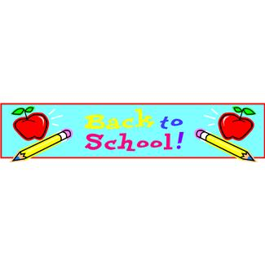
Mrs. Mooney
Mrs. Seemann
Mrs. Friend

